**Computer Engineering and Mechatronics MMME3085**

**Laboratory Exercise 1 output screenshots:**

* 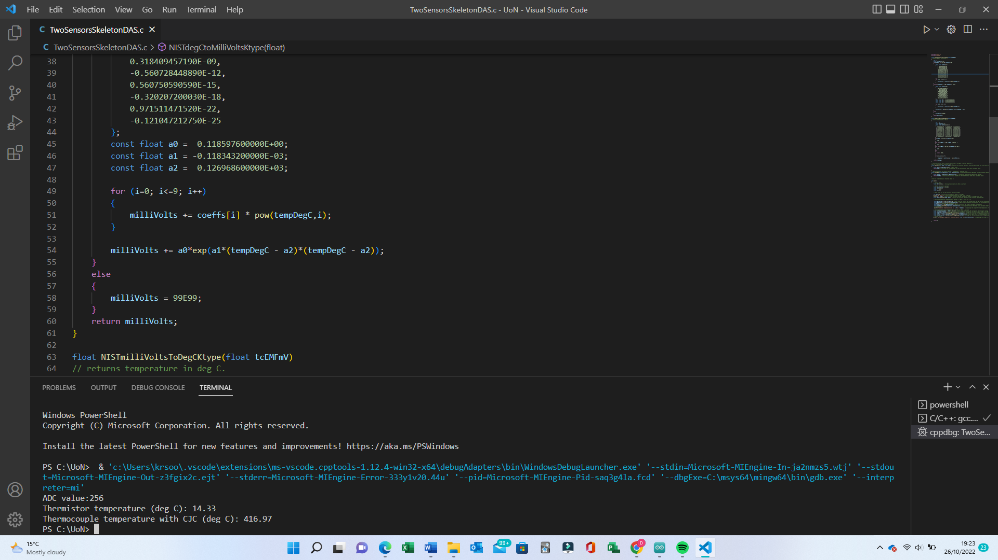Two sensors
* 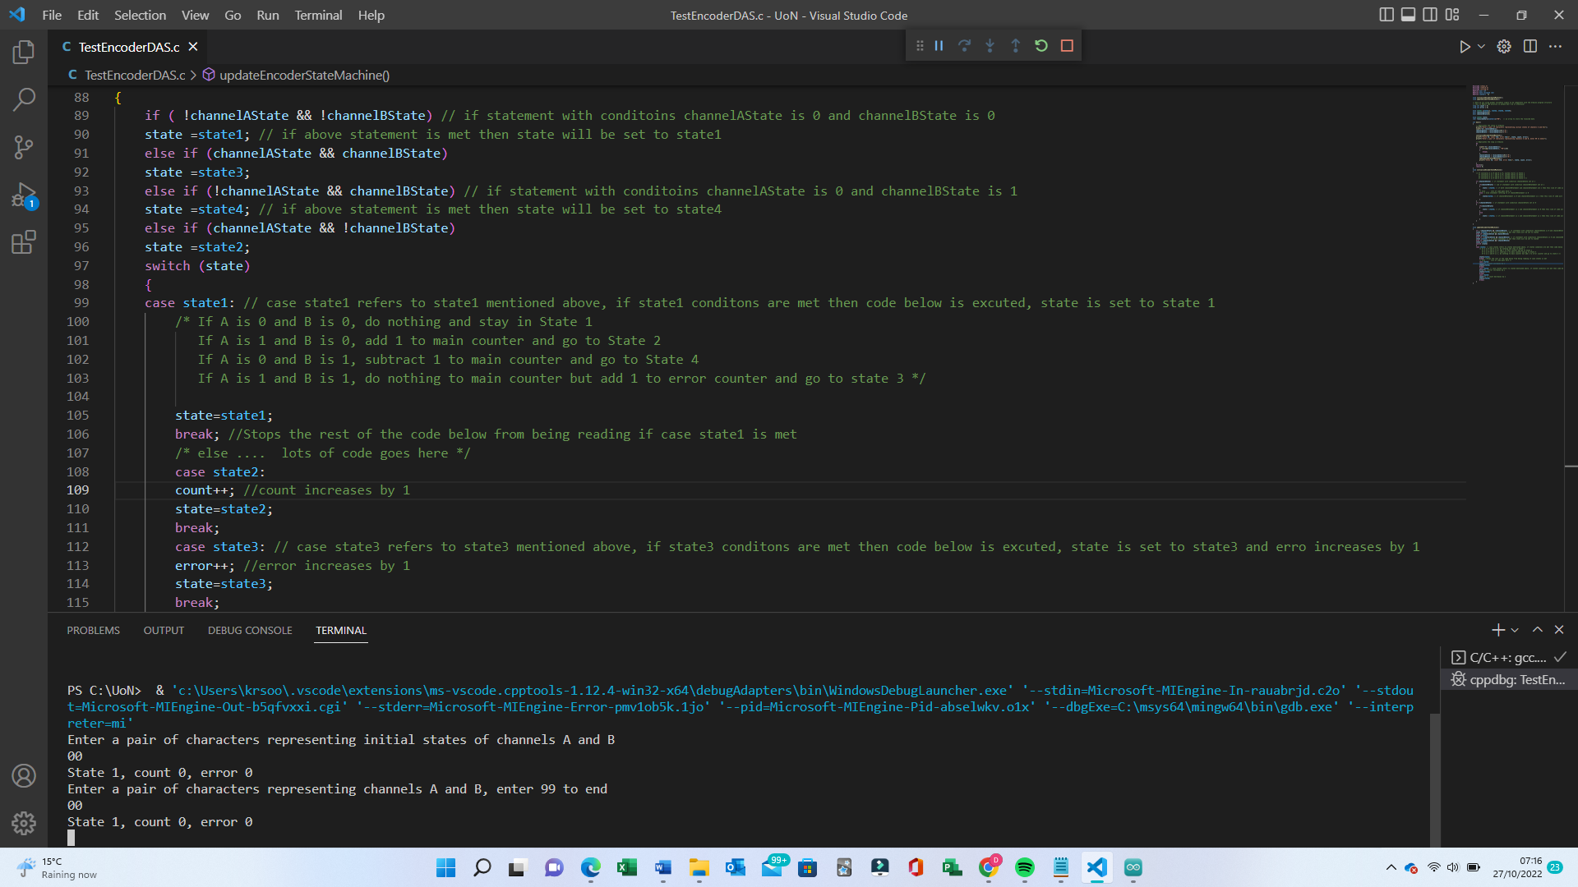Test Encoders (00,00)
* 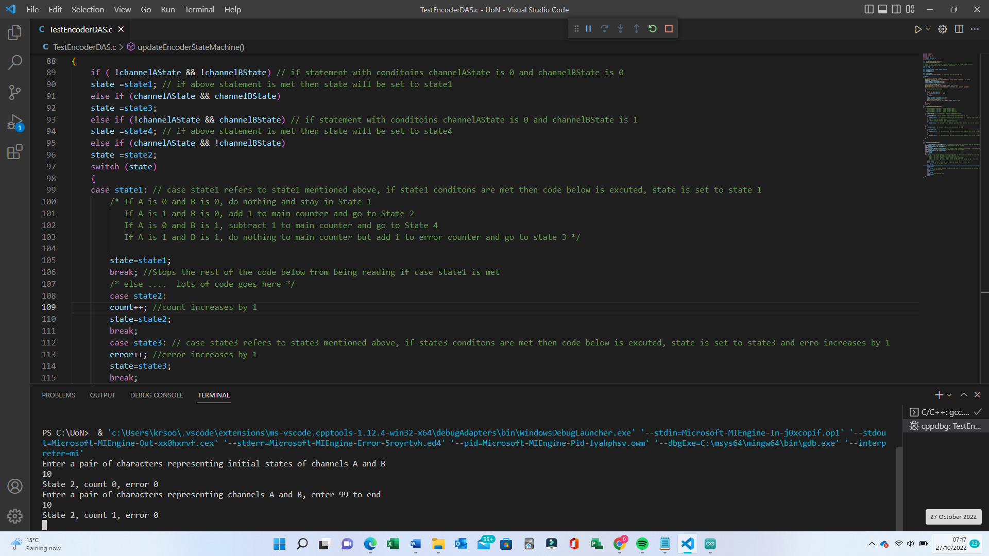Test Encoders (10)
* 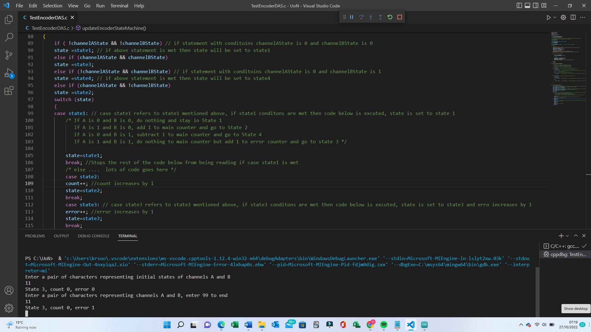Test Encoders (11)
* 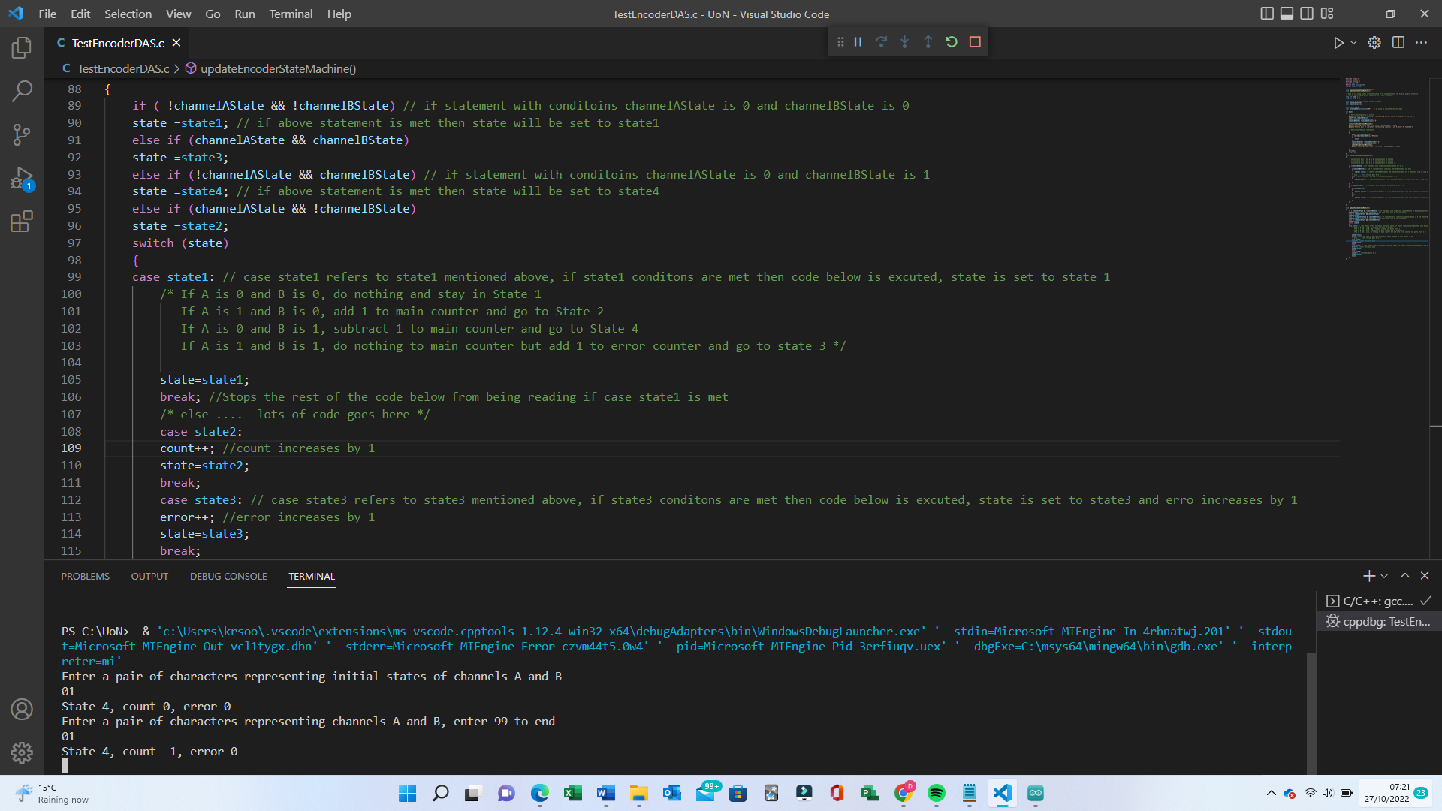Test Encoders (01)
* A screenshot of a computer

  Description automatically generatedTest Encoders (99)